**DAILY ONLINE ACTIVITIES SUMMARY**

|  |  |  |  |  |  |  |  |  |
| --- | --- | --- | --- | --- | --- | --- | --- | --- |
| **Date:** | **26/05/2020** | | | | | **Name:** | **VIRESH** | |
| **Sem & Sec** | **4th SEM & ‘B’ SEC.** | | | | | **USN:** | **4AL18CS097** | |
| **Online Test Summary** | | | | | | | | |
| **Subject** | | **DESIGN ANALYSIS OF ALGORITHMS** | | | | | | |
| **Max. Marks** | | **30** | | **Score** | | | **25** | |
| **Certification Course Summary** | | | | | | | | |
| **Course** | **Python for Machine Learning** | | | | | | | |
| **Certificate Provider** | | | **Greatlearning Academy** | | **Duration** | | | **5.0 Hrs.** |
| **Coding Challenges** | | | | | | | | |
| **Problem Statement:** Given an array A of size N where the array elements contain values  from 1 to N with duplicates, the task to find total number of subarrays which start and  end with the same element. | | | | | | | | |
| **Status: Done** | | | | | | | | |
| **Uploaded the report in Github** | | | | | **Yes** | | | |
| **If yes Repository name** | | | | | **Lockdown-Coding**  <https://github.com/viresh-kulal/Lockdown-Coding/blob/master/triangularnumbers.c> | | | |
| **Uploaded the report in slack** | | | | | **Yes** | | | |

**Online Test Summary: Today 18CS42 test was scheduled from 09:15 am to 10:00am .The portion for the IA was 1st module there were 30 questions and the time assigned was 45 minutes the questions were MCQ type.**

**The snapshot of the completion of the test and the marks allotted is attached here.**

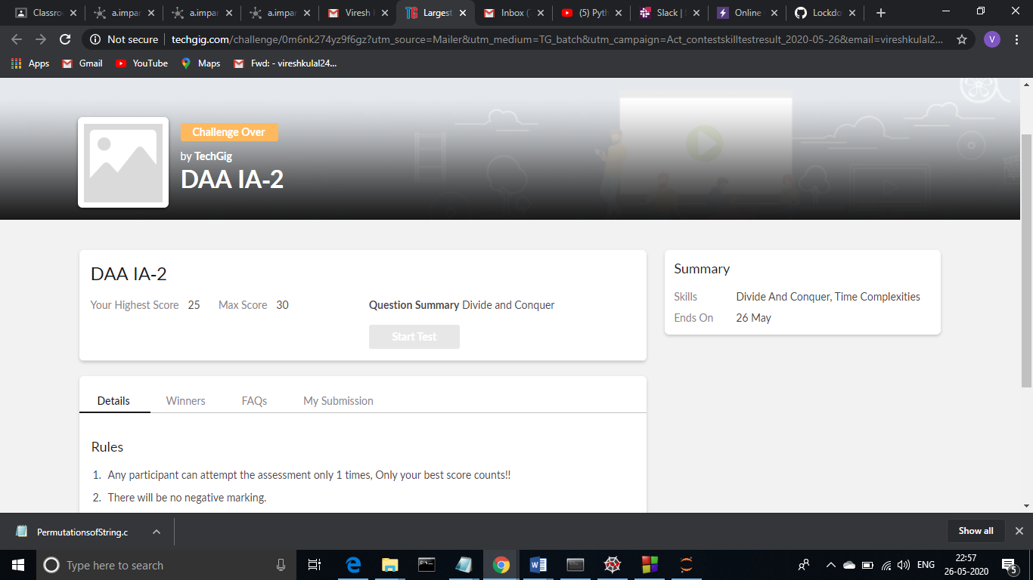

**Online Certification Course Summary: In today’s session, I have learnt about pandas introduction, pandas-series and dataframes and also I have learnt about access and modifying in pandas and its examples.**

**The snapshots of today’s course is attached below.**

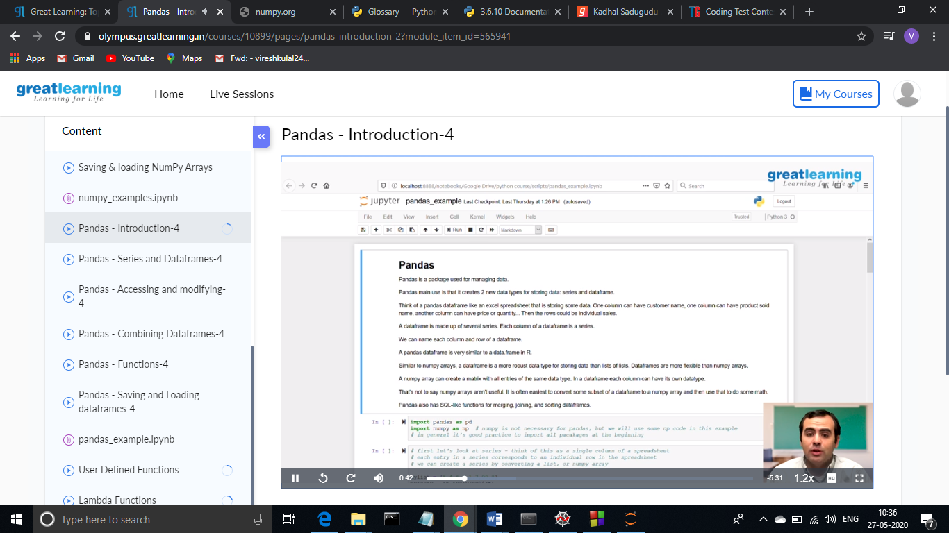 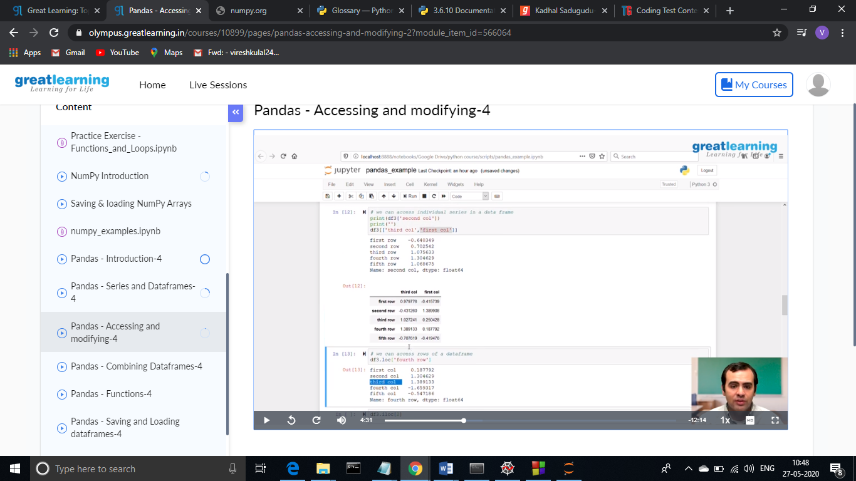

**Online Coding Summary: Today I had received one program from prof.Venkatesh CSE Dept. The programs is mentioned above(pg.01). I have uploaded it to my Github repository.**

The Repository Link is: <https://github.com/viresh-kulal/Lockdown-Coding>

And the snapshots of the program PermutationsofString.c is attached below.

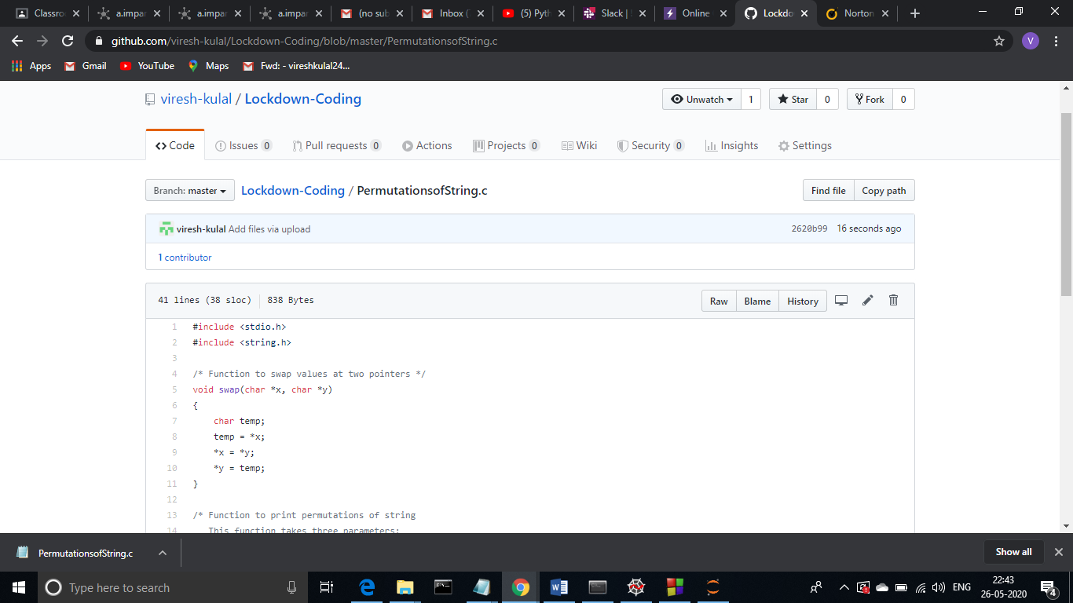

**Thank you.**